|  |
| --- |
| Telephone: 03 9357 3579  Email: [fawkner.ps@edumail.vic.gov.au](mailto:fawkner.ps@edumail.vic.gov.au)  Website: [www.fawknerps.vic.edu.au](http://www.fawknerps.vic.edu.au)  Principal: Roger Pell  Assistant Principal: Rosa Arena |
| **Important Dates** |
| July 2019 |
| 15th - Term 3 Commences  25TH – Chocolate Drive commences |
| August 2019 |
| 1st - Foundation 100 days  2nd **- CURRRICULUM DAY**  **NO SCHOOL FOR STUDENTS**  6 – 9 th – School Dental visit  26th Years 1 & 2 Yarra Valley incursion  29th Father’s Day stall |
| September2019 |
| 2nd – Years 1 & 2 CERES excursion |

|  |
| --- |
| TERM DATES 2019 |
| Term 1: 30 January –5 April.  Term 2: 23 April—28 June  Term 3: 15 July—20 September  Term 4: 7 October—20 December  **DOG THERAPY**  C:\Users\06125170\AppData\Local\Microsoft\Windows\INetCache\Content.Outlook\17N1344P\13.jpg |

Fawkner News

19th July 2019



**Dear Parents,**

Term 3 is generally a fairly quiet one. With the weather being colder and unpredictable we generally don’t have many excursions or visitors, but we do have lots of quality, fun learning time with few disruptions. We encourage children to run around at recess and lunch time unless it is raining when they stay inside, supervised by teachers.

**Dental Van visit.** From August the 8th the Mobile School Dentist will be visiting us at Fawkner Primary School. They will be providing a free dental check for children who have returned a completed form. If there are any concerns from the consultation parents will be contacted accordingly. If you have not yet received a form, visit the office where you can pick up a form.

**Staffing.** Late last term Ms. Rashelle Kelly was successful in applying to teach in a school in Geelong where she will teach for the rest of this year. Rashelle lives in Geelong, so this is a great opportunity for her to work much closer to home. We wish Rashelle all the best, and trust that working where she lives will be a positive experience for her and her family.

**2019 Camp. Parent information night.** We have organised to run a parents information session for this year’s Grade 3-6 parents, so that parents who would like more information about our camping program can come along, have a look at what happens and ask questions. This will begin at **6.00 on Wednesday July 31**. Usually these sessions run for about an hour. Camp is in the first week of Term 4.

**Curriculum Days.** School Council has approved a Curriculum Day on Friday August 2 as well as **Monday November 4th.** This is the day before the Melbourne Cup public holiday (Tuesday November 5th.) **Monday 4th November.**

**Swimming program, Term 4.** Our swimming program will begin in the first week of Term 4.

**Father’s Day activities**. This year Father’s Day is on Sunday September 1st. We will be having our Father’s day stall on **Thursday 29th August** and a special Dad’s, Grandads, uncles, big brothers etc. day on **Friday August 30th**. Invitations will go home closer to the day.

**Athletics Sports.** The annual Athletics. Sports are being held towards the end of the term. Children will be involved in trialling for the various sports throughout the term.

|  |  |
| --- | --- |
|  | **Canteen**  Starts on Monday 22nd July.  Monday, Wednesday & Friday |

**School terms 2019**

Term 3: July 15 – September 20 (2.30 finish)

Term 4: 7 October—20 December

|  |
| --- |
| **Students reporting on activities at school.** |

**Dog therapy - Term 2 2019**

In term 2 some of the 5/6s got the opportunity to participate in a dog therapy program. In the group there were 10 students that participated. Every Thursday morning they would get to go to the BER building and got to learn about mindfulness and our emotions. The name of the teacher was Jasmin and the dog’s name was Lucy. I really enjoyed it because we got to learn and pat Lucy at the same time. The last session was fun because we got to go outside and play with Lucy. Everybody in the group really loved spending an hour each Thursday with Lucy and Jasmin. We would like to thank Jasmin and Lucy for coming to our school and doing the dog therapy program with us. We would also like to thank Carmela for organizing this program for us.

**By Portia Greenacre**

In Term 2, some of the 5\6’s got the chance to participate in a dog therapy program. Students were very happy to be in this wonderful program, Every Thursday morning the 5\6s would go to see the dog. The dog was named Lucy and tutors name was Jasmine. The theme was mindfulness and our emotions. There was 7 weeks to spend time with Lucy. I really enjoyed working with Lucy, I got to give her some pats and give her some yummy treats! Sadly the last week was very sad since we won’t see Lucy again but we learnt to be calm. Each Thursday we had an hour with Lucy! We love to thank Lucy, Jasmine and Carmela for letting us doing this program and I hope she can come and visit us! Thank you for everything!

**By Lina Rizki**

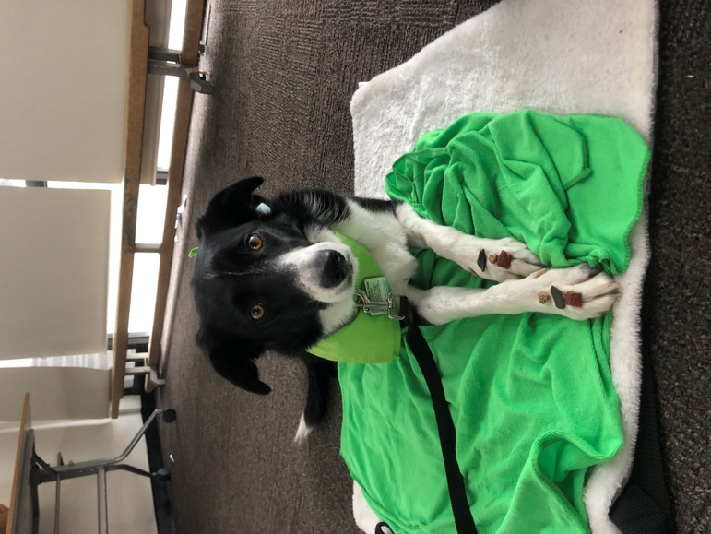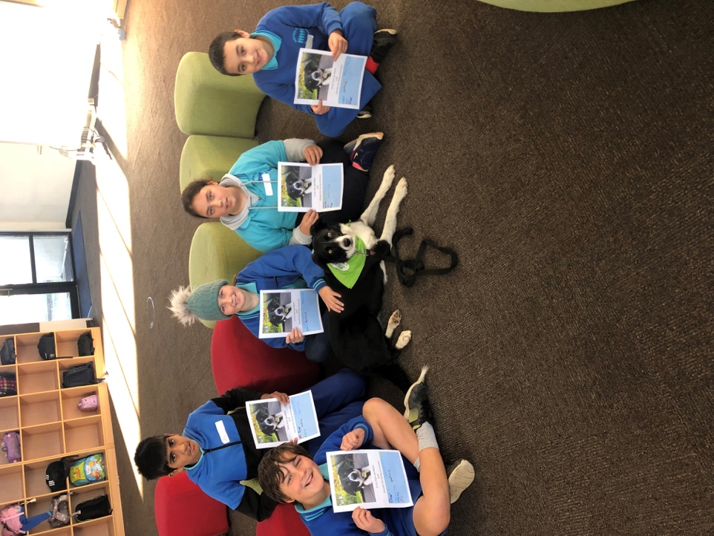



**Doxa Camp—Malmsbury**

**for children in Years 3, 4, 5 & 6**

Dear Parents,

This year’s camp we will be going to Doxa Camp—Malmsbury. We are holding an information night for all children from grades 3—6 and their parents. On the night you will have the opportunity to ask all those

questions you have ever wanted to know about camp. We will also be showing some photos/videos of

activities from previous camps. This gives you an opportunity to see the different types of activities the

children participate in and of course the children enjoying themselves.

**We hope to see all parents and children from years 3-6!**

**When: Wednesday 31st July Time: 6pm Where: Staffroom**

Who can come: Parents and children from years 3, 4, 5, & 6

**In order for us to arrange seating could you please return the slip below by**

**Monday 29th July 2019**

Yes/No - My family can attend the camp meeting

Name: …………………………………………… Class………………… Number attending ……….

|  |  |
| --- | --- |
|  | Community News |

**FREE courses at Fawkner Community House in Term 3.**

* Basic English, Literacy and Numeracy Skills (Level 1)
* English for Work (Level 2)
* More English! (Level 3)
* English for Job Search Skills
* Microsoft Office 10 Level 11
* English for Forms and Tests
* Computers for Italian Seniors

Call now 9386 9418 to enrol for Term 3.

MO0MBA PARK TENNIS CLUB

276 McBryde St Fawkner

Any girls/women who are interested in learning how to play tennis – we have some funding to assist financially. The classes will commence soon.

Contact Shirley 0405-976366

