Telephone: 03 9357 3579
Email: fawkner.ps@edumail.vic.gov.au
Website: www.fawknerps.vic.edu.au
Principal: Roger Pell
Assistant Principal: Rosa Arena
Important Dates
August 2019
2nd - CURRRICULUM DAY
NO SCHOOL FOR STUDENTS

5– 9th – School Dental visit
26-30th Literacy/Numeracy Week
26th Years 1 & 2 Yarra Valley incursion
29th Father’s Day stall
30th- Father’s Day activities
September2019
2nd – Years 1 & 2 CERES excursion
5th – Foundation Incursion
Kids Science
10th 5 & 6 Imax/Museum Excursion
12th – 3 & 6 Museum Excursion
TERM DATES 2019
Term 1: 30 January –5 April.
Term 2: 23 April—28 June
Term 3:
15 July—20 September

Term 4: 7 October—20 December

100 DAYS OF SCHOOL ON THE
1ST AUGUST 2019

Fawkner News
1st August, 2019

Dear Parents,

Please remember there is no school for the children tomorrow, August 2nd. Staff will spend the day looking at resources and programs to further enhance every child’s learning opportunities.
NEDS visit. Our visiting artist, Keith, from NED’s inspired our children to buy a yo-yo and have a go at mastering some tricks. It has been very pleasing to see so many children trying something new. NED’s stands for N Never give up, E Encourage others, D Do your best. The NED’s program encourages children to persevere and try their hardest when they are doing things that might be a bit hard. These are traits we also encourage every day at school.
Dental Van visit. From August the 5th the Mobile School Dentist will be visiting us at Fawkner Primary School. They will be providing a free dental check for children who have returned a completed form. If there are any concerns from the consultation parents will be contacted accordingly.
Curriculum Days. School Council has approved a Curriculum Day on Friday August 2 as well as Monday November 4th. This is the day before the Melbourne Cup public holiday (Tuesday November 5th.)
Swimming program, Term 4. Our swimming program will begin in the first week of Term 4.
Father’s Day activities. This year Father’s Day is on Sunday September 1st. We will be having a special Dad’s, Grandads, uncles, big brothers etc. day on Friday August 30th. Invitations will go home closer to the day.
Athletics Sports. The annual Aths. Sports are being held towards the end of the term. Children will be involved in trialling for the various sports throughout the term.
Prep. enrolments. If parents have any family members, neighbours, friends etc. who have a Prep. aged child for 2020 could you encourage them to enrol the child as soon as possible please. We can sit down and help parents complete the enrolment form here at school, and this will greatly assist us with our planning for next year.
Children coming late to school. Unfortunately we are experiencing a number of children who are now in the habit of getting to school after 9.00. It is important that children learn to be organised and responsible. If they get into the habit of being on time to school, then they will value their education more and increase their chances of educational success. Parents should ensure children are out of bed early enough to get to school on time. We recommend children do what they need to do at home, eg. eat breakfast, get dressed, pack school bag etc. and not get distracted by television or other electronic devices before school.
Chocolate Drive. A special thank you to all the people who have been involved in the chocolate drive, whether it be helping to organise it, selling them or just eating (and paying for) the chocolates. Just a reminder that the chocolate drive is a school fund-raiser, so all money and unsold chocolates should come back to the school.

Student Achievement Awards.

FDG | Mariam Riaz | 12M | Ali Ali & Zuni Syeda
56M | Julian Saliba | 56R | Musa Kimura

News from around the school.

Netball Challenge – Student ‘v’ Teachers. End of term 2.
 | 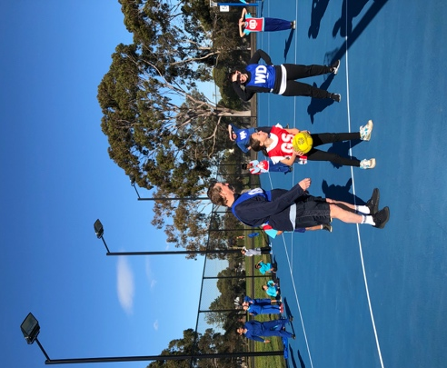 | 