Telephone: 03 9357 3579
Email: fawkner.ps@edumail.vic.gov.au
Website: www.fawknerps.vic.edu.au
Principal: Roger Pell
Assistant Principal: Rosa Arena
Important Dates
2020
See below for this terms Calendar
TERM DATES 2020
Term 1:
29 January – 27 March
Term 2:
13 April – 26 June
Term 3:
13 July – 18 September
Term 4:
5 October – 17 December.

First Day for Foundation Students
Fawkner News
12 February, 2020

TERM DATES 2019
Dear Parents, A special welcome is extended to all our new parents, as well as those who have been with us previously. We are always excited to meet new families and look forward to supporting you and your children throughout these vitally important school years.
We have had an excellent start to the year. Our Foundation students and other new children have all settled in beautifully, and all the children have made a very positive start to their schooling. Our school numbers continue to grow. Currently we have just under 285 students, As always we continue to have an excellent tone of behaviour among the children, both inside the class and in the yard. It has been great to see the older children looking after the newer students, and generally acting out our motto of “Caring and Sharing”
Staffing. We warmly welcome back to our school two teachers who have been on Family Leave for a number of years.
Ms. Asli Yuksel. Asli has completed seven years of Family Leave, and returns to school for two days per week. Asli will be one of the teachers running our Arts program.
Ms. Rebecca Strangis also returns after seven years of Family Leave. Rebecca will be the Grade teacher in 1/2R on a Friday.
We are thrilled to have Asli and Rebecca back with us and joining our great group of staff members. Included in this newsletter is a full staffing list for your information.
Before and After School Care. We are on track to have our Before and After School Care program begin late in Term 1 or at the start of Term 2 at the latest. We are currently waiting for the relevant Govt. departments to complete the application process, but are hopeful that we will have the program running by the start of Term 2 at the latest.
Parent Teacher meeting. Wednesday March 4. This first meeting is really about sharing information and getting to know each other. The school places special importance on having a positive relationship between school and home as it is extremely important that the school staff and families work together to ensure educational success for each child. Further details of our first get together will be sent home soon. This year we are continuing with the booking system where parents can book a time to see the teacher via the internet, using www.schoolinterviews.com.au You will be asked to enter a code: 3acvv then put in your details, then select the teachers you wish to see, and select the times that suit you. The site is live now, so you can book your time now. We will send home a separate note with the information in the next couple of days as well.
We encourage all parents to attend with their child to meet with the teacher.
Assemblies to be held on Mondays at 3.00. This year we will have our Assemblies on Monday afternoons at 3.00. All parents, family and friends are welcome and encouraged to attend. Our assemblies are held in the new building.
Breakfast Club. This year our Breakfast Club will operate on Tuesday and Wednesday. Children can come along to the staff room, where we will provide breakfast of Uncle Toby’s Cheerios, Vita Brits, muesli, fruit salad or toast. Children are welcome to come to the staff room between 8.30 and 9.00. There is no cost for this. Children will be supervised eating breakfast and will be able to go out to play or go straight to their classes after they have eaten (and helped clean up).
Playgroup. Our very successful Playgroup will continue to operate, this year on a Monday. Playgroup operates from 9.00 – 10.30. one day per week in the Kindergarten building. Parents and young children who don’t attend Kindergarten or school are welcome to attend. Please speak to the office staff if you would like more information.
Canteen. Our canteen will begin operating from next Monday. Canteen operates on Monday, Wednesday and Friday. We are always looking for volunteers to help do this very important task. New parents are always welcomed. We cannot run the canteen without volunteers, so we really do ask parents to consider helping out occasionally so the school can run the canteen. Parents can speak to Annette in the office at any time regarding the foods we sell and anything else. Volunteers only need to commit to three hours on a canteen day. If we don’t have volunteers to support the school we won’t be able to operate. If you think you can help, please contact Annette in the office.

Nut products. We occasionally have students who have an allergy to nut products. This allergy can be extremely serious and potentially life-threatening. Even the slightest trace can be dangerous to children. We ask that all parents NOT send to school foods that contain nuts, particularly Nutella, peanut butter and snack bars like Snickers, Picnic and even muesli bars that contain nuts. We realize this may cause inconvenience to you, but ask that you find other fillings for sandwiches for your children and not send products to school that contain nuts in the interests of safety for others. We also ask you to reinforce with your children the importance of washing their hands after meals.
Important notes:
Arriving on time. Could parents please ensure children are at school before 9.00 as it is important that every child is here ready for the day by the scheduled start. It gets them into good habits and they don’t miss out on important learning time.
School hat. Please note that during Terms 1 and 4 all children should be wearing a school hat whenever they go outside while at school. This is part of our School Sun Smart program that helps children learn about positive life habits. Hats are available to be purchased from the office.
Label all property. Could parents please write a name on all jumpers, hats, lunch-boxes, drink bottles etc.
2020 Information Book. Shortly we will send home our Information Booklet for 2020 that parents find useful for information on most things to do with the school.

PRIVACY INFORMATION for parents and carers

During the ordinary course of your child’s attendance at our school, school staff will collect your child’s personal and health information when necessary to educate your child, or to support your child’s social and emotional wellbeing or health in the school context. Such information will also be collected when required to fulfil a legal obligation, including duty of care, anti-discrimination law and occupational health and safety law. If that information is not collected, the school may be unable to provide optimal education or support to your child, or fulfil those legal obligations.
For example, health information may be collected through the school nurse, primary welfare officer or wellbeing staff member. If your child is referred to a specific health service at school, such as a Student Support Services officer, the required consent will be obtained. Our school also collects information provided by parents and carers through the School Entrance Health Questionnaire (SEHQ) and the Early Childhood Intervention Service (ECIS) Transition Form.
Our school may use online tools, such as apps and other software, to effectively collect and manage information about your child for teaching and learning purposes, parent communication and engagement; student administration; and school management purposes. When our school uses these online tools, we take steps to ensure that your child’s information is secure. If you have any concerns about the use of these online tools, please contact us.
School staff will only share your child’s personal or health information with other staff who need to know to enable the school to educate or support your child, or fulfil a legal obligation.
When our students transfer to another Victorian government school, personal and health information about that student will be transferred to that next school. Transferring this information is in the best interests of our students and assists that next school to provide optimal education and support to students.
In some limited circumstances, information may be disclosed outside of the school (and outside of the Department of Education and Training). The school will seek your consent for such disclosures unless the disclosure is allowed or mandated by law.
Our school values the privacy of every person. When collecting and managing personal and health information, all school staff must comply with Victorian privacy law. For more information about privacy including about how to access personal and health information held by the school about you or your child, see our school’s privacy policy: https://www.education.vic.gov.au/Pages/schoolsprivacypolicy.aspx

Throughout this notice, ‘staff’ includes principals, teachers, Student Support Service officers, youth workers, social workers, nurses and any other allied health practitioners and all other staff at our school. This includes employees, agents and service providers (contractors) of the Department, whether paid or unpaid.

Term 1 calendar 2020
 |  | ASSEMBLY – MONDAY’S AT 3.00
27 Feb | Years 5 & 6 | Excursion -Parliament House
28 Feb | Foundation | Incursion - Moreland City Council
3 Mar | Years 5 & 6 | Tennis Program commences
4 Mar |  | PARENT / TEACHER INTERVIEWS
10 Mar | 1/2M & 1/2W | Incursion – Hands on Science
11 Mar | 1/2C & 1/2R | Incursion – Hands on Science
13 Mar | 2/3S & Years 3 & 4 | Excursion - Scienceworks
18 Mar | Whole School | SCHOOL PHOTOS
27 Mar |  | End of term 1 – 2.30 finish

School terms 2020
Term 1: January 29- March 27 (2.30 finish)
Term 2: April 14 – June 26 (2.30 finish)
Term 3: July 13 – September 18 (2.30 finish)
Term 4: October 5 – December 17 (1.30 finish)
Foundation 2020 .
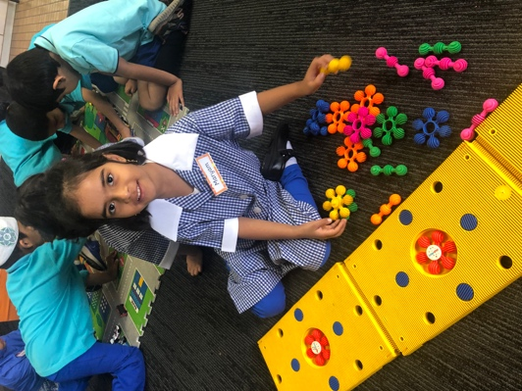
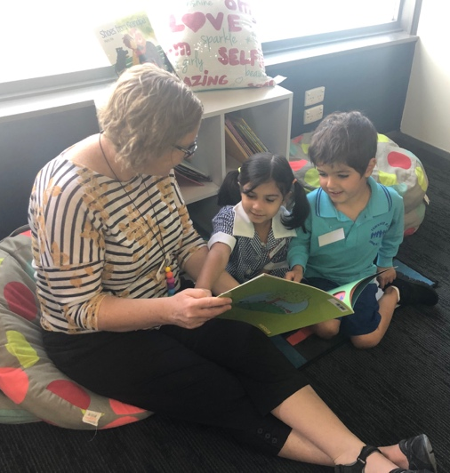
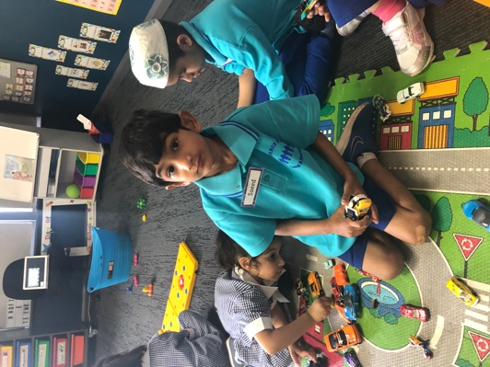

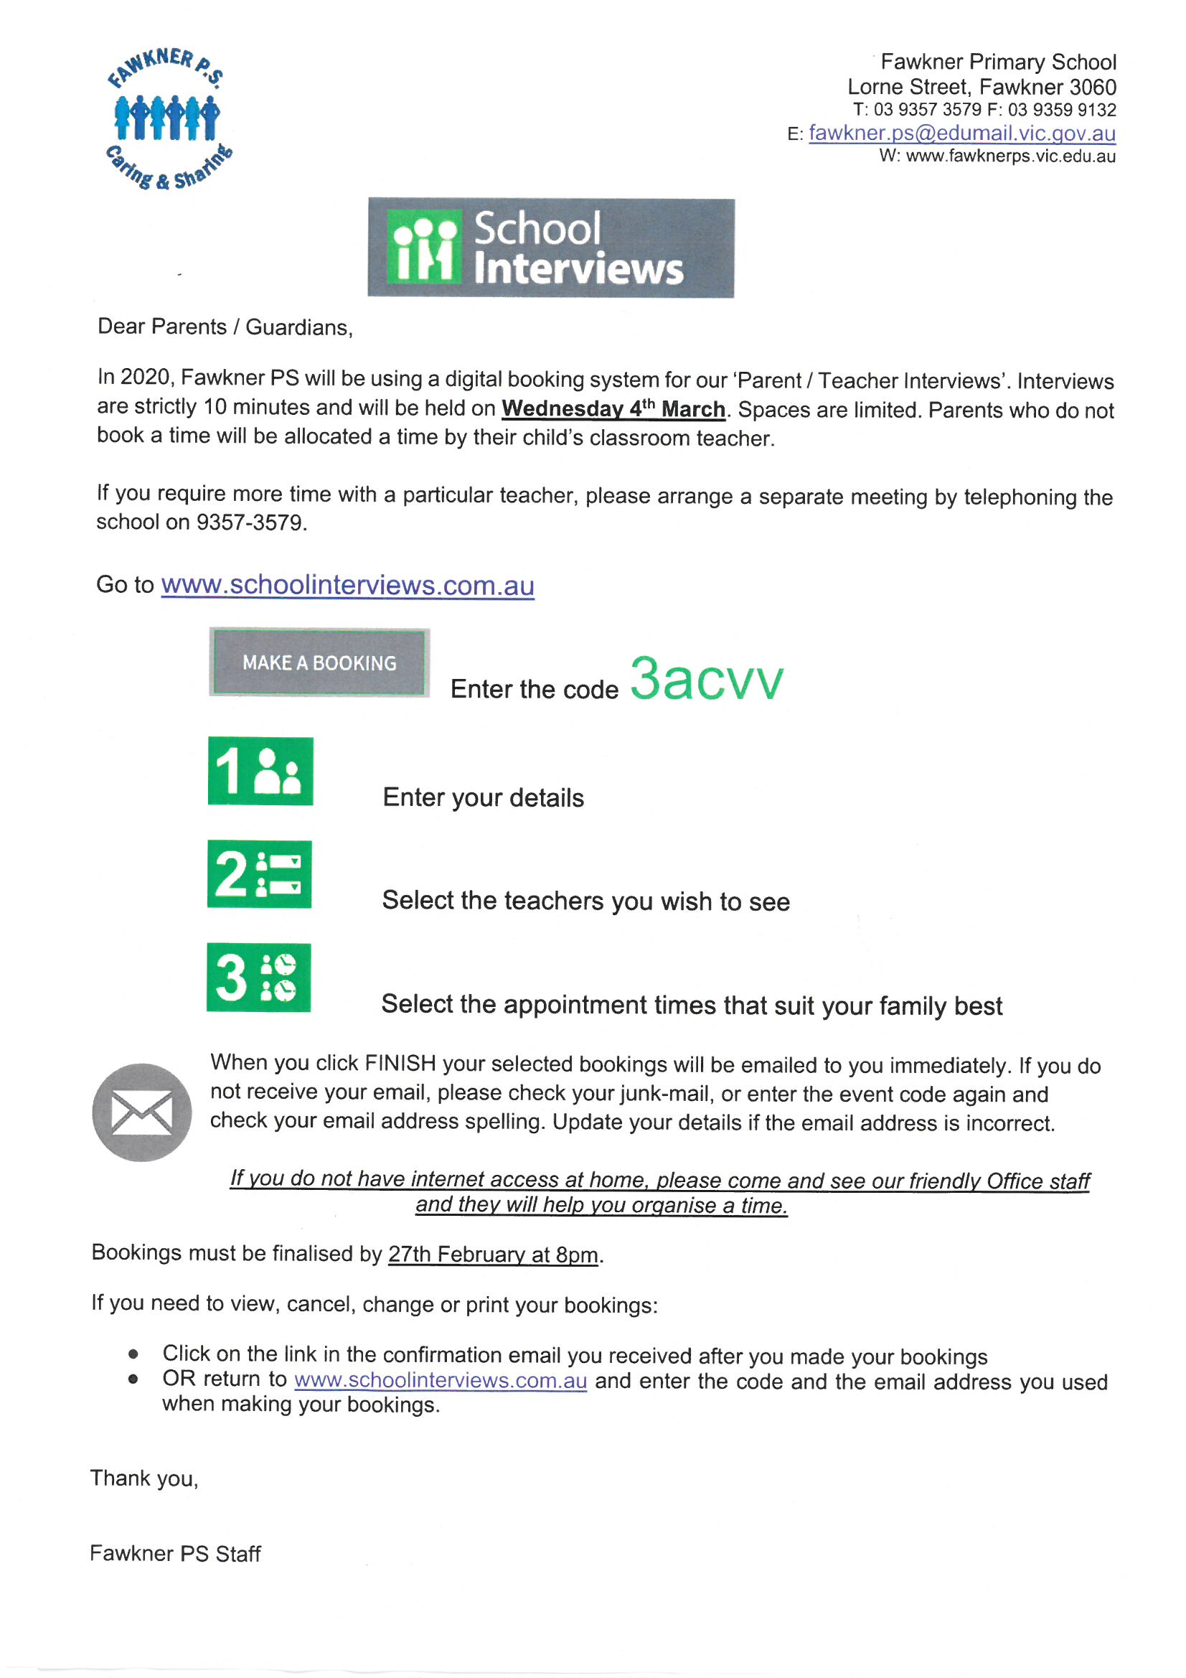

SENTRAL
To improve the efficiency of our school’s administration system we use Sentral, an online student administration platform. The use of Sentral will be rolled out in stages and will include online roll marking, student achievements, reports, Interview bookings and a parent notification system.
In order for us to use Sentral, we need to use your child’s information which we currently hold at school including your child’s photo, enrolment and achievement details. This information is uploaded to Sentral via a secure online portal. This enables us to exercise our duty of care and assists us in creating optimal learning environments for all students.
Our Principal has overall responsibility for Sentral, however to ensure the running of the system is optimised all staff will have access to the data.
The data is stored in Australia on a centralised databases. The data is encrypted and will not be shared with any third parties.
For information about this school’s privacy obligations and how we handle personal and health information please see the Department’s schools privacy policy:
https://www.education.vic.gov.au/Pages/schoolsprivacypolicy.aspx

ESSENTIAL ASSESSMENT
To improve the assessment of our students we use an online tool provided by Essential Assessment. It provides highly individualised data for the classroom teacher which assists in them in meeting the needs of our students and enables them to report with greater accuracy your child’s achievement data and progress.
In order for us to use Essential Assessment, we need to use your child’s information which we currently hold at school including your child’s photo, enrolment and achievement details. This information is uploaded to Essential Assessment via a secure online portal. This enables us to exercise our duty of care and assists us in creating optimal learning environments for all students.
Our Principal has overall responsibility for Essential Assessment, however to ensure the running of the system is optimised all teaching staff will have access to the data.
The data is stored in Australia on a centralised databases. The data is encrypted and will not be shared with any third parties.
For information about this school’s privacy obligations and how we handle personal and health information please see the Department’s schools privacy policy:
https://www.education.vic.gov.au/Pages/schoolsprivacypolicy.aspx

Community News
